Ideation Phase
Brainstorm & Idea Prioritization Template

Date | 13 June 2026
Team ID | 24EG105E03
Project Name | HOUSEHUNT_BHAVITAGANJI
Maximum Marks | 4 Marks

HouseHunt – Brainstorming and Idea Prioritization
Problem Areas:
- Difficulty finding rental houses in one place
- Lack of centralized rental platforms
- Manual communication between owners and renters
- Difficulty managing rental property listings
- Time-consuming house search process
Generated Project Ideas:
- House Rental Management System
- Online Doctor Booking System
- Complaint Registration System
- E-Commerce Platform
- Event Management System

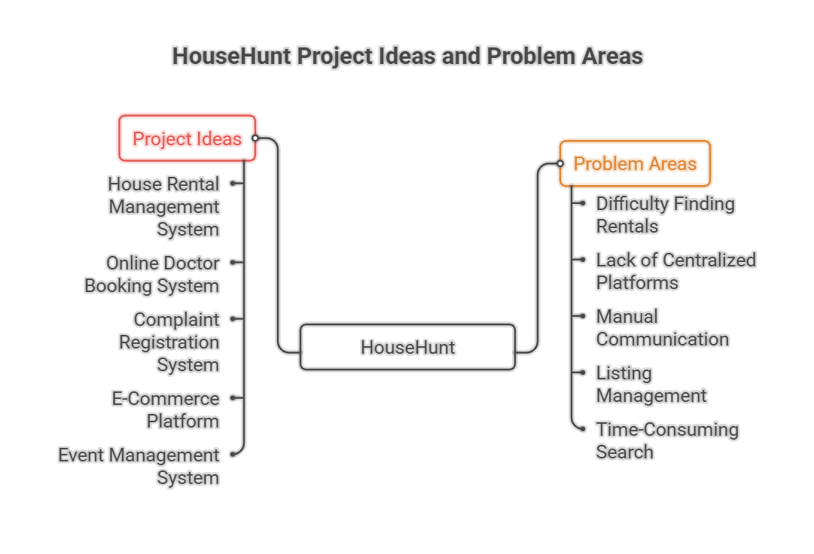
Impact vs Effort Analysis:
High Impact, Low Effort:
- House Rental Management System
High Impact, High Effort:
- E-Commerce Platform
Medium Impact:
- Online Doctor Booking System
- Complaint Registration System
Selected Idea:
HouseHunt – House Rental Management System
Reason for Selection:
- Solves a real-world problem
- Suitable for MERN Stack implementation
- Demonstrates CRUD operations
- Includes authentication and authorization
- Easy to understand and demonstrate academically
- Can be extended with advanced features in the future
